PINE RIVERS MENS SHED Newsletter
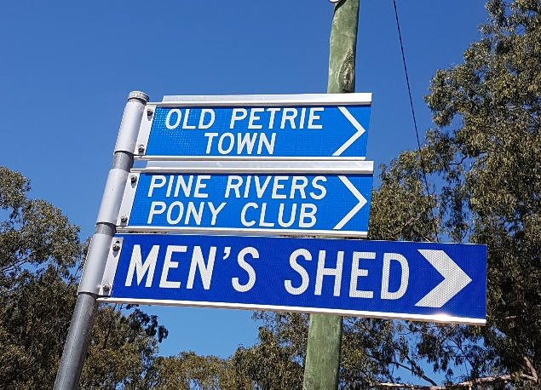
February / March 2022

We have kicked off the year well with a few great projects in the workshops and of course the regular Bunnings BBQ’s bringing in the regular $$$.
All PRMS members are always grateful to all those guys who do those BBQ’s.
Remember guys, they are always looking for help with the BBQ days.
Please… Putchahandup!
Or better still write your name & phone number on the BBQ day list.

We are all looking forward to this coming Friday 4th when hopefully we can chill out a bit and not be restricted with these Masks. The upside being that we will actually know who we are talking to, the down side will be we can see each others faces again!
Don’t be throwing your masks away, you will see in the pic there are other uses.
But seriously… let’s not get complacent, let’s take all the care we can by NOT coming to the shed with any illness, even if you think it is just a light head cold, STAY AWAY… we are all older and more vulnerable and none of us need any illness, no matter how insignificant it might be.

Apparently before my time the Shed used to do “Organised Outings”.
These outings dropped away before Covid and of course never kicked off again.
Our President Jeff has suggested perhaps it is time to kick these off again so we are looking for suggestions of places to go please.

From the Social Side of the Shed.
Overall winners for all the tournaments played during 2021.

Pool. Phil Scorey
Pool Doubles. Ken Adamson &
Murray Bean
Snooker. John Nowell
Euchre. Mike Nicholson

We Have started our 2022 Tournament. I’ve also included a time frame for all games to be played by. For those who are playing Pool & Snooker can you try & get your game finished by the dates on the sheets, Thanks.
That way we will be able to get round 2 in by June.
Hopefully we will have 4 rounds for the year then the play-offs for the 2022 winners.

We had our first Euchre Tournament for the year on Friday 25th February. It went well with 12 players nominated to play. We lost 2 players because of the rain & flooded roads. The scoring wasn’t high with Rick Oakes winning the day with 64 points and Phil Scorey coming 2nd with 60 points.
Next Euchre Tournament will be 25th March.

Hopefully I may be able to do a Breakfast on the 18th March.
See how many members we get to the shed after the “Mandatory Mask wearing stops”.
Because of the amount of rain and flooding we are experiencing now there may be major clean-ups at your own homes and your areas, so to all members and there families stay safe and look after one another, Cheers… Chris Owen.

From the Workshops Recently.
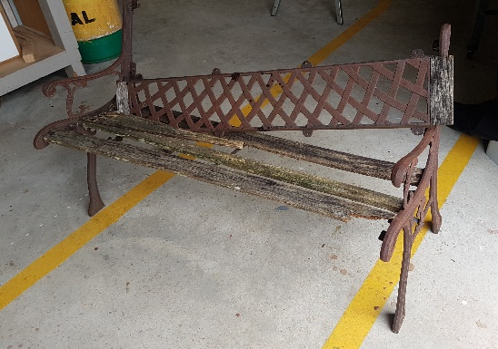
This pile of bits was delivered for a restore…
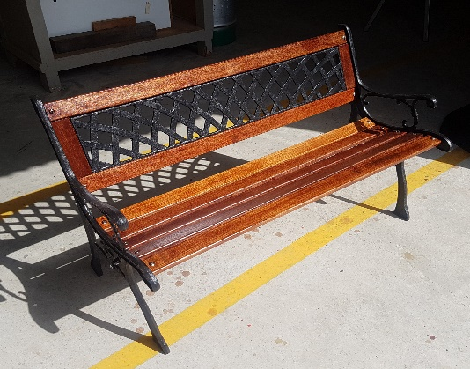

And here it is looking perfect.

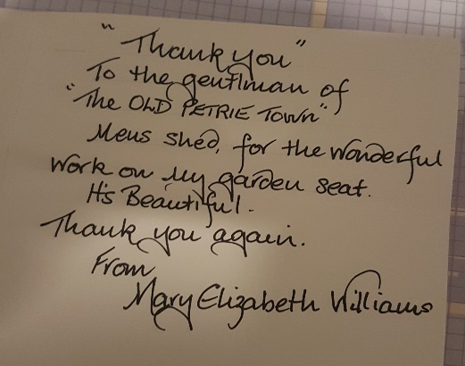

We even received a thankyou card for the service.

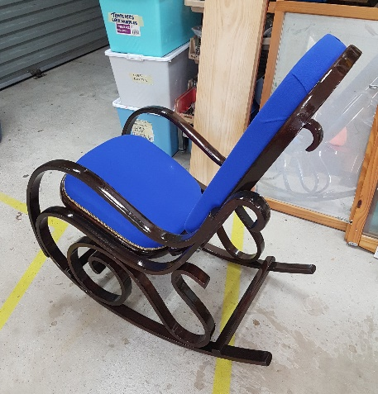
This great old Rocking chair believed to be from the 1920’s was also beautifully restored and sold to a lucky member of the Shed.

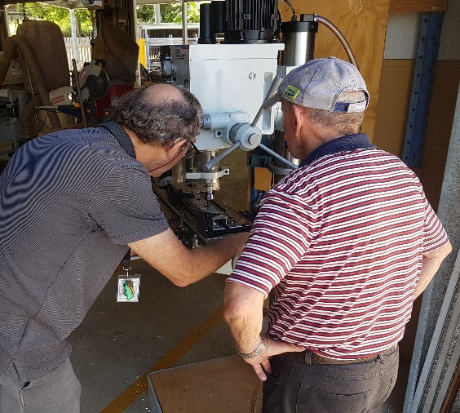
The new Mill Drill in action.

It is a great addition to our Shed and it has already done a few jobs.

Safety Tips from the PRMS
Safety Department.

Heavy materials or Items should always be stored on the lowest shelf possible.

