PINE RIVERS MENS SHED Newsletter
2021 CHRISTMAS &
End-of-Year EDITION
From the Pine Rivers Mens Shed committee we wish all members and their families a safe and happy Christmas and New Year.
See you in 2022 !!!

Here we are at the end of the year!
I’m sure you will all agree its been another great year for PINE RIVERS MENS SHED, this is because of ALL OF YOU,
THE SHED MEMBERS!
You guys are what make this shed GREAT!.

Lets all be grateful for the simple things in life like Smiles, Laughter, Friends, Good Health and Life itself. Those 5 things can’t be bought, no matter how much cash you have.
Lets also all come back next year with a positive, happy outlook on life and for our time together here at the shed.
No Drama = Happy & Healthy Shed

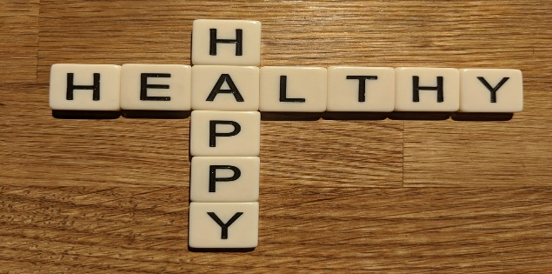

We had our Christmas lunch at Old Petrie Town, I took quite a few pictures, far too many to add to the Newsletter,
I have however recently posted them up on the
Pine Rivers Mens Shed Facebook Page
If you wanted some or all of them sent to your email please just ask me and I will send them through to you.
Most of us enjoyed the occasion, sure we got a few complaints but at the end of the day when an event is organised like this, never ever will 100% of the members be happy, that’s just life.

On behalf of all the members I like to express our thanks and gratitude to some members from time to time, this time it is Mike Nicholson.

Mike is the first point-of-contact for most of us.
He has an uncanny warm, happy, friendly and welcoming personality which is not naturally born into all of us, we all see him chatting calmly and patiently to the new recruits and showing them around the shed.
I’m sure you will all agree…
“hats off and special thanks to Mike for doing this job”.

Grant Round Up For 2021
2021 was a relatively successful year for grants, in all the shed applied for 5 grants and were awarded 4.
Early in the year the shed gained a grant of $35,000 from the Gambling Community Benefit fund to be put towards the proposed shed extension. Also a small grant from Bendigo Bank was obtained for a new computer for the Committee.
This month the shed was notified that our request for $20,000 from the Stronger Communities grant was unsuccessful, but a grant for $4925 for more equipment for the shed from the Volunteer Grants and $1719 for First aid Courses and Manuals from the National Shed Development Program were awarded.
Hopefully in 2022 the shed will be more successful.
Just a note the Road Traffic Authority have asked that I remind you do not Drink and Drive, given the state of Queensland roads you are likely to hit a pot hole and spill the drink.
Seriously please stay safe and drive carefully may you all have a very happy Covid free Christmas and a healthy and prosperous 2022.
Robin Latchem. Grants/Executive Officer

Because of the fantastic generosity of large donations from one of our respected members we have been able to buy some new gear for the workshops.
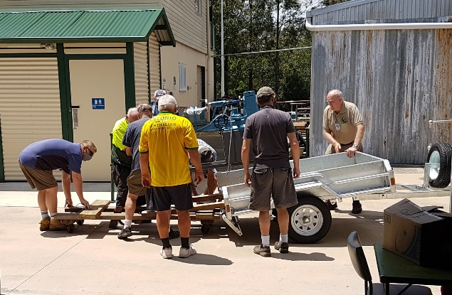The lads unloading a beautiful new Large Wood Lathe

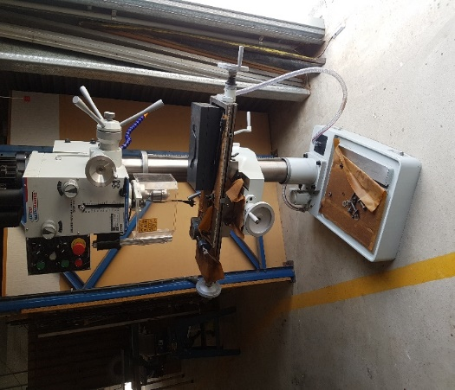
We also now have a Mill-Drill, this is the type of machine that will not actually get used often, however when it is used it will make a lot of
jobs very much easier and safer and enable us to do things we couldn’t previously do.

From the workshops…

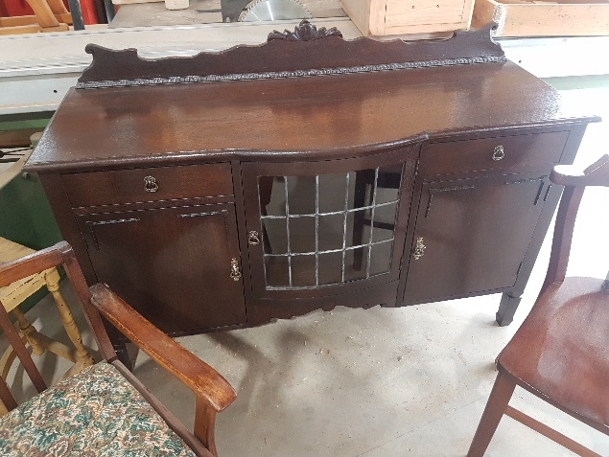
I hope you all got to see the incredible restoration of this cabinet, The picture does not do it any justice and also unfortunately I forgot to take a pic of it prior to the restore but it literally looked like a pile of rubbish when it arrived, it turned out to be a complete success and the customer was absolutely wrapped.
Top marks to Noel, George, Rick and anyone else that was involved.

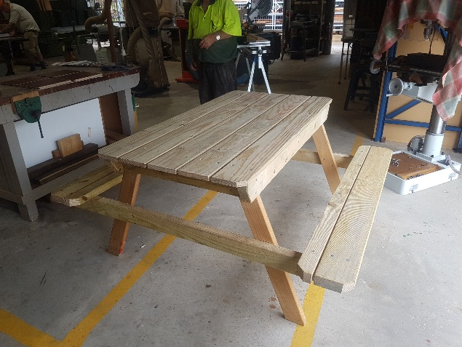
A Picnic table has also been made and we hope to get future orders for these.
Please share this with your friends and relatives, we can make and sell these for approximately 60% of the best price anyone can get anywhere else.
Over the past few months a lot of you would have seen the clocks hanging up in the Small Shed, We had days when we wondered what would become of them all, never fear… over the last few weeks they have been very popular and have sold many.
They are a great novelty gift.
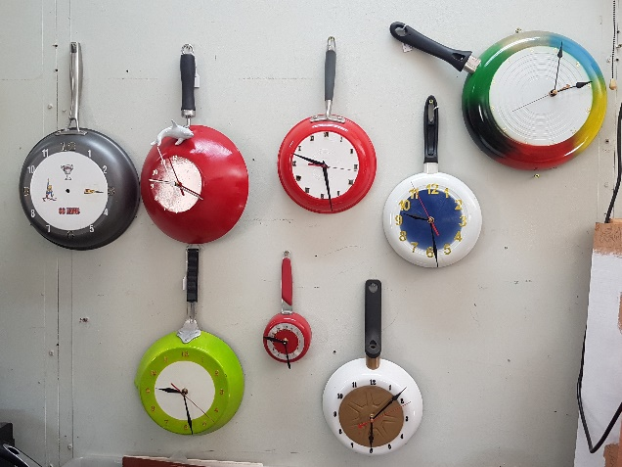
Doug and Paul are now offering to do Custom Orders for members, what ever your colours or theme or subject, just have a chat with them, they will design and make something suitable.

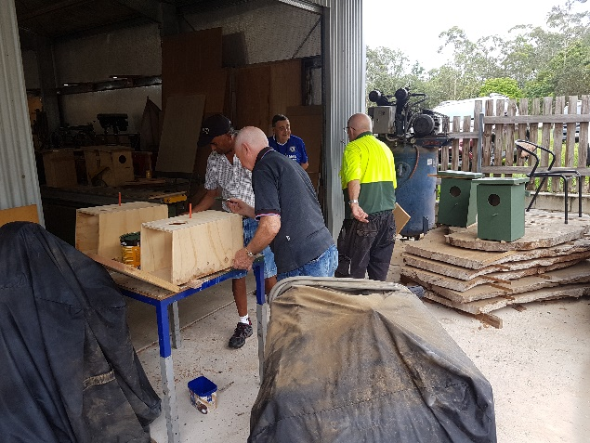
Possum Boxes getting the final touches.

