PINE RIVERS MENS SHED Newsletter
Sept - Oct 2021
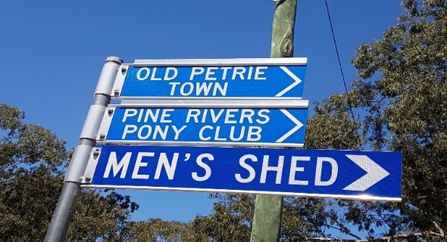

25 August was our Annual General Meeting.
An average turnout considering masks are mandatory at this time and not comfortable for some.

Thanks to Bob from
for joining us on this day.
The meeting went smooth with minimal changes to the committee, this proves they have done and are doing a fine job of managing our Shed.
Many thanks to Phil Scorey for his services for the past couple of years who stood down from Vice President position, to which I was nominated and will do my best to fill Phils Shoes and help Jeff when he needs coffee or a pie!!!
… watch that space!...
that’s really going to happen!...

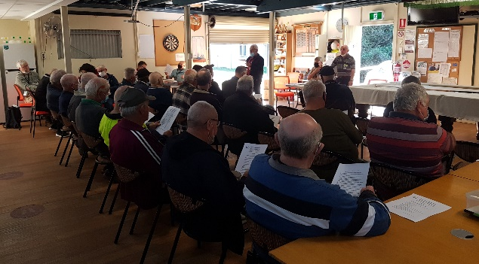

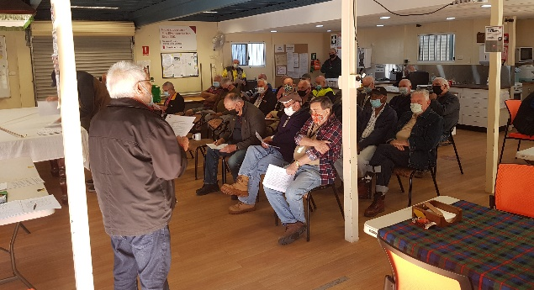

As most of you know there is a huge amount of work being done on setting up Health & Safety & Insurance documents & procedures for the Shed. This will also include an updated Induction process for all members current and new.
This is a huge assignment mainly being done by Robin and Peter.
All respect to these 2 guys for the untold hours of their own personal time into research, reading, writing, checking and rewriting numerous times until they are satisfied. On top of this Sal & Richard are also reviewing & checking as the documents progress.
We all know anything to do with Health & Safety & Insurance are very complex because of the infinite variables, but once these documents & systems are in place they will cover our shed to the “best of our ability” and will be a great step forward to keeping our Shed safe and secure for all.

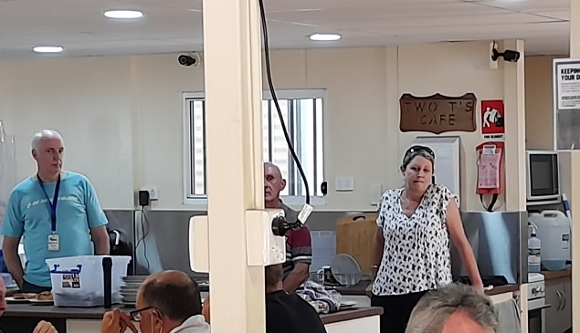
Rhondi, the new Old Petrie Town Manager giving us a briefing on the upcoming SteamFest which was held on the weekend of 25 – 26 September.
For the first time we had an “Open Shed” for the 2 days,
This was our first and we learned a lot. We created a bit of interest and managed to flog off a few of our wares.

Thanks to all who got involved, these things can’t happen without support from the members.
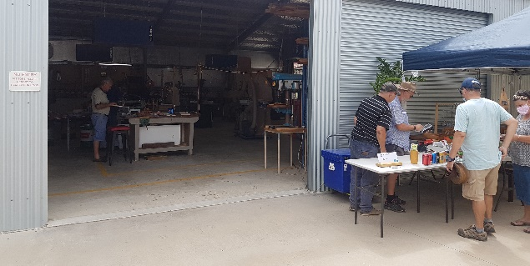
John and Russell were giving Scroll Saw Demonstrations
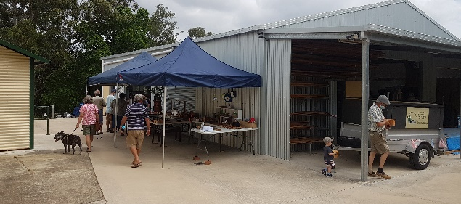
(to the right of pic) One of Leos Trucks going to its new owner

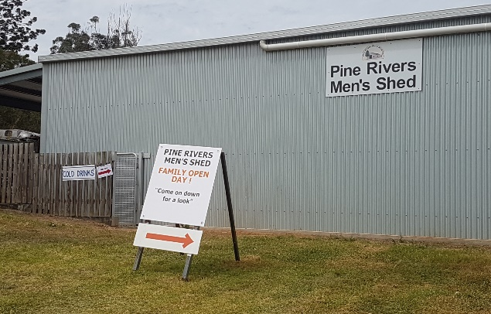
This position is where we hope to have our Stall next time, this was facing a lot more activity & we think will help sales.

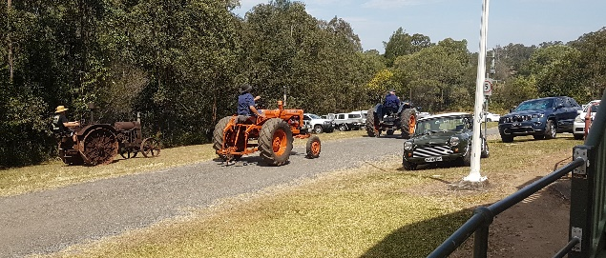
Tractor Grand Prix past our shed.

Recently we have made some funds by selling donated items, the Brand new dishwasher for example (thanks Gordon for your generosity, much appreciated) & a Freezer & Ricks restored Cabinet.
All these things help keep our shed going comfortably.
If you have something that you no longer want or something that needs a repair and you think it could be sold, please talk to me before you bring it in and I will see if it’s a possible easy sell fundraiser towards the Shed.
From the Workshops
A lot has been coming out of the workshops over the last few weeks, all adding precious dollars to PRMS thanks to all involved.
The following pics show just “some” of what has been achieved recently.

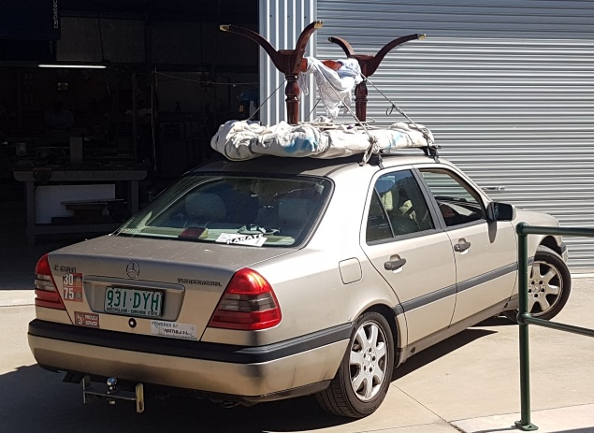
The “Famous” restored Antique table finally found a new home. Off it went tied to the top of a “Vegetable oil fuelled Mercedes” not kidding!.
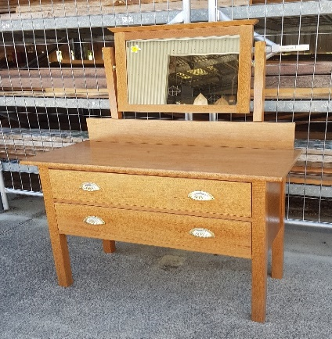
Duchess Dresser donated and restored at home by Rick in his
own time.
Sold by PRMS, all proceeds to the Shed. Thanks Rick.

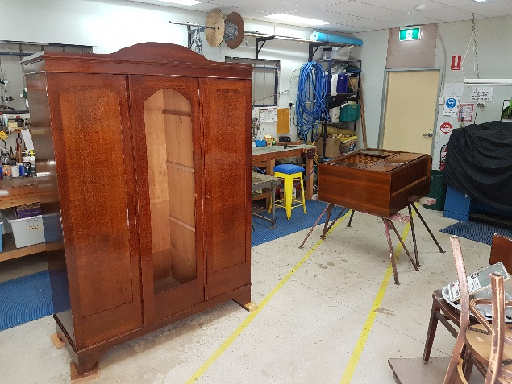
Big old Wardrobe & Record Player Cabinet repaired-modified & resprayed.
------------------------------------------------------
I want to give our thanks and appreciation to the Blokes that do the Bunnings BBQ’s.
This is the steady reliable income that our Shed needs, its usually the same bunch of guys who take part in these and they rarely get recognized for their effort and input of their personal time.
Please help if you can.
To add to that, a special thanks to Chris Owen who not only organises the social activities at the Shed (pool, Cards, Breakfasts etc) but also makes a huge effort to organise and push the BBQ’s.
These things would not happen if it wasn’t for members like this, you have to wonder, how would the shed be without people like Chris?.
Hats off and thanks to all of you.

